|  |  |  |  |
| --- | --- | --- | --- |
| echa_logo  bande_Bleue | | | |
| Data Management Platform | | | |
| **Authority Consultations**  **Business Requirement Report**  TrasysInternational-LD - RVB | | | |
| Contract: | |  | |
| File location: | | | Project directory\-\- |
| Ref.: | FWC10 - SC14 -3.2\_AuthorityConsultationInformation\_BusinessRequirementReport.docx | | |

Status information

|  |  |  |  |  |  |
| --- | --- | --- | --- | --- | --- |
| Security classification: | Restricted | | State : | | Final |
| Current version number: | 1.5 | Date of first issue : | | | 12/06/2020 |
| Prepared by: | Nikolaos Kollaros | | | Date: | 17/09/2020 |
| Verified by: |  | | | Date: | 30/01/2023 |
| Approved by: | -- | | | Date: | --/--/---- |

Copyright notice

This document may not be reproduced (even partially) or communicated to third parties without the written authorisation of the company’s General Management.

Circulation / distribution list

| Name | Address | I/A | Name | Address | I/A |
| --- | --- | --- | --- | --- | --- |
|  |  |  |  |  |  |
|  |  |  |  |  |  |
|  |  |  |  |  |  |
|  |  |  |  |  |  |

*(I = for information, A = for action)*

Document change record

| Version | Date | Description | Affected sections | Prepared By |
| --- | --- | --- | --- | --- |
| 1.0 | 30/10/2019 | Initial version | All | Nikolaos Kollaros |
| 1.1 | 20/12/2019 | Updated version due to the finalization of the data model provided by DyCa side | 4, 13, 14 | Nikolaos Kollaros |
| 1.2 | 20/02/2020 | Updated version to adjust specifications due to changes of Consultation Module data model. | 14 | Nikolaos Kollaros |
| 1.3 | 12/06/2020 | Updated version to incorporate adaptions required to support a) High volume triggering b) Data latency |  | Nikolaos Kollaros |
| 1.4 | 17/09/2020 | Updated version to embed the DMP’s physical interface | 12, 13.1.2, 13.1.3 | Nikolaos Kollaros |
| 1.5 | 26/01/2023 | To support IP's need to identify if BAP Case is root/parent or leaf/child in a Process Map | 4.5, 13.1.6 | Nikolaos Kollaros |

Table of contents

1. Introduction 5

1.1 Purpose 5

1.2 Scope 5

1.3 Objectives 5

1.4 Structure 6

1.5 References 6

1.6 Abbreviations 7

Part A Project Drivers and constraints 8

2. Stakeholders 9

2.1 Data Management Platform (DMP) 9

2.2 Dynamic Case (DyCa) 9

2.3 Consultation Management module (Consultation tool) (CT) 9

2.4 Interact Portal (IP) 9

3. Actors & Roles 10

4. High Level Business Requirements 11

4.1 Source system 12

4.2 Integration 13

4.3 High Volume triggering 13

4.3.1 Context 13

4.3.2 Functionality 14

4.4 Data latency publication 14

4.5 Support IP to link to ACT process details 15

5. EDM Coverage Conceptually 17

6. Assumptions & Constraints 18

PART B Functional Requirements 19

7. Use Cases 20

7.1 UC-CONS-01. Retrieve data related to Authority Consultations 20

7.2 UC-CONS-02. Propagate data to Interact Portal 20

8. IP Data Requirements 22

9. Business Rules 28

9.1 Authority consultations 28

PART C Non functional Requirements 29

10. Maintenance 30

PART D Interface Requirements 31

11. Inbound 32

11.1 Adaptations to support High Volume triggering and Third Party Consultations 34

12. Outbound 36

12.1 Physical Interface for Consultations data domain 36

PART E APPENDIX 37

13. Logical Data Model 38

13.1 Master data 38

13.1.1 Consultation 38

13.1.2 Batch of Consultations (high volume triggering) 40

13.1.3 Consultation User 41

13.1.4 Subject of Consultation 42

13.1.5 Consultation Documents 43

13.1.6 Case entity 45

13.2 Reference data 45

# Introduction

## Purpose

The purpose of the document is to capture the functional and non-functional requirements of the Integration of Authority Consultations information produced in the Consultation tool of Dynamic Case and promoted - via DMP - to Interact Portal.

## Scope

The scope of the work included in this report captures the data related to Authority Consultation and are originated from two interrelated but discrete sources: The Consultation Management module (Consultation tool) and Dynamic Case.

Moreover, in this version of the document (1.3) the scope extended to cover all tasks related to the project work for integration authority consultation data for Interact Portal referring to:

* Resolving the **data latency** aspects requested by IP
* Additional data needs related to the **High volume triggering** mechanism in the Consultation module

**Note:** There is no need for additional data related to the on-boarding Observers since this functionality affects only the way of selecting consultees of an Authority Consultation and this does not have any impact to data structure, content or process thereafter.

## Objectives

While the aforementioned purpose and scope states the overall direction, the document intents to achieve following objectives with their stated meaning:

* **Correctness**: accurate and valid description of the system functionality as perceived by all project stakeholders. The word all deserves particular mention since there are numerous project stakeholders not always sharing the same expectations for certain aspects of the system functionality. If such cases occur, the document should capture the decisions taken that satisfy all project stakeholders.
* **Completeness:** all the intended functionality should be included in the document without omissions and without neglecting to explain important concepts. The context of completeness is functional, therefore it should not contradict with conciseness (see below), which has a general context. In rare cases where the two objectives are found to be contradicting, then completeness should be considered as a higher priority and take precedence.
* **Unambiguousness:** explicit and comprehensible descriptions conveying only one meaning and in particular the intended meaning. Wording should be carefully chosen such that it leads any reader to the intended interpretation, thus avoiding misapprehensions. Moreover, the words denoting business concepts should be established and consensual terms from the business vocabulary.
* **Consistency:** the document follows a defined and predictable structure. In addition, the functionalities specified throughout the document should not be conflicting with one another and the same terms should be used for the same concepts without conflicting statements.
* **Conciseness:** while the document should capture all important aspects (see completeness objective above), it should avoid lengthy and comprehensive explanations and instead aim at simplicity and compactness in a way that is useful and manageable. Towards this objective, conceptual models are used to capture the subject matter entities and their relationships following industry standard semantics and notation.

## Structure

The document is structured as follows:

* Introduction: provides a general introduction to the document.
* Part A Project Drivers and Constraints: provides a brief description of
  + Stakeholders involved and their role in the current implementation.
  + High level Business Requirements
  + EDM Coverage on conceptual level
  + Assumptions and constraints that should be taken into consideration during the implementation of the specific demands.
* Part B Functional Requirements: provides the functional requirements following the use case approach along with the related business rules.
* Part C Non Functional Requirements: provides the non-functional requirements.
* Part D Interface Requirements: provides the interface requirements (inbound / outbound).
* Part E Appendix: provides any supportive material.

## References

|  |  |  |
| --- | --- | --- |
| **Ref.** | **Title** | **SharePoint / Confluence Link** |
| **R01** | ECHA Interact – Inception Phase II, Panagiotis Nikolaou | [link](https://echa.sharepoint.com/sites/ecm/echainteract/Shared%20Documents/ECHA%20Interact%202018/99%20Inception/Authority%20Consultation/Requirements/Requirements%20specification%20-%20Consultation%20-%20Interact%20Inception%20Phase%20II%20(2018-2019).pdf?CT=1563277269967&OR=ItemsView) |
| **R02** | D28.2.1 - Requirements specification document for the Consultation Tool, Orestis Fotiadis |  |
| **R03** | DMP IP Consultation Business Request v1.3, Athina Scandalou |  |
| **R04** | Consultation tool, Data latency, ECHA presentation, 21/10/2019 |  |
| **R05** | Consultation scenario, DyCa & Interact Portal - Consultation Module, Athina Scandalou, 02/04/2019 |  |
| **R06** | Consultation Module – Consultation DB views, Stefanos Kolovos, 13/12/2019 |  |
| **R07** | Consultation process, Vangelis Papanastasatos, 12/12/2019 | [link](https://echa.sharepoint.com/:p:/r/sites/ecm/echainteract/Shared%20Documents/ECHA%20Interact%202019/01%20Requirements%20Analysis/02%20Consultation%20functionality/Consultation%20-%20EDM%20-%20Approach.pptx?d=wef0f745e7d9c4c49802b962ea39f666a&csf=1&e=C76Auj) |
| **R08** | Consultation Module – Consultation DB views, Stefanos Kolovos, 27/5/2020 |  |
| **R09** | DMP IP Consultation Business Request v1.4, Angeliki Zografidou | [link](https://teams.microsoft.com/l/file/1E1E04BF-D8CF-4470-97BD-6CA680E7A2BA?tenantId=9d1545f9-02be-47ed-9202-11ef4d057f1e&fileType=docx&objectUrl=https%3A%2F%2Fecha.sharepoint.com%2Fsites%2FInteractPortal%2FShared%20Documents%2FChange%20Management%20Stream%2F02.%20Analysis%20%26%20Specifications%20Documents%2FIP%20v3.0.0%2FHigh-Volume%20Consultations%2FDMP%20IP%20Consultation%20Business%20Request_v1.4.docx&baseUrl=https%3A%2F%2Fecha.sharepoint.com%2Fsites%2FInteractPortal&serviceName=teams&threadId=19:35c91085556f427786c72231f400bf36@thread.skype&groupId=3ad33aa4-1e39-4e72-abb8-bfc146f0ad7c) |
| **R10** | D26.3-5 – ECHA – Interact Portal v.3.0: WP1.1 Reduce the latency in the propagation of consultation data/ WP1.2 Adaptations to support Public Consultations / WP1.3 High Volume consultation triggering: Requirements specification document, Orestis Fotiadis | [link](https://echa.sharepoint.com/sites/ecm/echainteract/_layouts/15/Doc.aspx?sourcedoc=%7BEB08423B-B646-4414-8833-AB8D0A9145D4%7D&file=DXX.X.X%20Requirements%20specification%20document%20for%20Public%20Consultation%20adaptations%20and%20High%20Volume%20Consultation%20Triggering.docx&action=default&mobileredirect=true) |

## Abbreviations

|  |  |
| --- | --- |
| **Abbreviation** | **Description** |
| **DMP** | Data Management Platform |
| **IP** | Interact Portal |
| **DyCa** | Dynamic Case |
| **ECHA** | European Chemicals Agency |
| **IAM** | Identity Access Management |
| **MSCA** | Member State Competent Authority |
| **NEA** | National Enforcement Authority |
| **EDM** | Enterprise Data Modelling |
| **XML** | Extensible Markup Language |
| **XSD** | XML Schema Definition |
| **RAC** | Risk Assessment Committee. |
| **SEAC** | Socio-Economic Assessment Committee |
| **TP consultation** | Third-party consultation (Formerly known as “public consultation”. Also abbreviated as TP consultation in this document.) |

Part A Project Drivers and constraints

# Stakeholders

## Data Management Platform (DMP)

Data Management Platform unifies data from several transactional, case management systems and flat files and makes them available to various consuming systems. It also produces business intelligence reports to facilitate day-to-day operations and decision making.

## Dynamic Case (DyCa)

Dynamic Case is one of the main Case management systems of ECHA. The assessment of the substance regulatory activities are handled within Dynamic Case and it is the source of the data required for both consumers’ PD and BO Universe.

## Consultation Management module (Consultation tool) (CT)

Dynamic Case is one of the main Case management systems of ECHA. The assessment of the substance regulatory activities are handled within Dynamic Case and it is the source of the data required for both consumers’ PD and BO Universe.

## Interact Portal (IP)

Interact Portal (hereafter IP) is a web-based application intended to give the authorities (MSCA and NEA) the EU Member States access to the information submitted to the European Chemicals Agency (ECHA). The national enforcement authorities (NEA) need access to this information to be able to effectively enforce the REACH and CLP Regulations. IP has been developed as a separate application from REACH-IT to accommodate the need for easy and secure access by numerous users from many locations in Europe. IP is one of the main consumer of DMP. In the context of the current demand, IP needs to consume on daily base data related to AFA.

# Actors & Roles

The following table specifies the actors and their role for describing the use case scenarios.

Table 2‑1

|  |  |  |
| --- | --- | --- |
| **Actor Code** | **Actor** | **Role** |
| **AC-01** | Interact Portal | Consumer |
| **AC-02** | Data Management Platform | Integrator |
| **AC-03** | Dynamic Case | Source |
| **AC-04** | Consultation Tool | Source |

# High Level Business Requirements

The functionality outlined in this document is covering the functional and non-functional requirements for successfully triggering a consultation from a) a Substance or b) Meeting Case in the DyCa application. With the implemented solution and appropriate service configuration, an authority consultation successfully triggered from DyCa is made available for viewing and comment provisioning to external users (i.e. SEAC members) via the Interact Portal. Once a consultation has been successfully triggered, the related external users will be able to access the connected case / meeting information, documents and subjects.

**Consultation** has been defined as the process of gathering comments or additional information on subject(s) that are currently being worked on by ECHA. Although the subject(s) are generally presented within documents that are made available by ECHA to the consultees, the consultees can submit comments/evidence about the subject/document, but cannot make amendments to it (i.e. the document is not editable). Public consultation is a good example of a process falling under this category.

For both authority and public Consultations, the schema depicts the flow of information, the role and the relationships of involved systems.

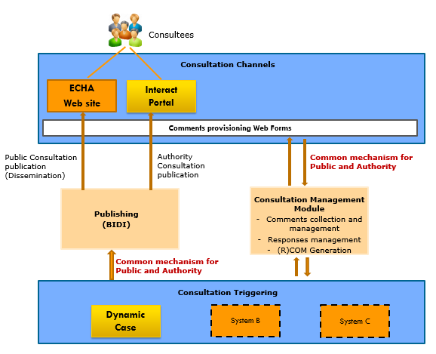

**Consultation triggering** is the sequence of actions where a DyCa user has selected to start a consultation service from the services tab of a DyCa substance or meeting case.

**Consultee** can be defined a user who, either directly or indirectly (through his group memberships, i.e. RAC Committee members) has been appointed as a consultee for an Authority consultation, can access the Interact Portal and through it can provide comments to a consultation. Any ECHA staff member may be defined either as consultee or comments responsible. At the same time, **User groups** (e.g. NEA Forum Members, NEA Forum WG, NEA BPRS Members, NEA BPRS WG, ECHA Expert Groups (PBT, ED and Nano, Accredited Stakeholders), MSCA REACH RiMe, RAC COMMITTEE Members) that are defined and managed in **Identity Access Management** (IAM) can be available to participate when triggering a consultation or updating an existing consultation instance.

**Subject** of consultation is an item upon which a consultee provides their comments. Each consultation instance contains one or more subjects.

## Source system

The case management system of ECHA, Dynamic Case, is the responsible system to trigger an Authority Consultation. Actions regarding Consultation (Create consultation, assign consultees, attach Documents, etc.) take place in the Consultation Tool module. For better understanding of the flow of information, it is important to define the terms used in DyCa environment:

|  |  |
| --- | --- |
| **Process Map** | It is the equivalent of the Case on the Enterprise Data model level. A set of DC Cases, which are used to depict an EDM Case |
| **Case event** | A timestamped transaction, occurring in the context of a case, which is deemed of such importance that it needs to be recorded |
| **Consultation instance** | An instance of the consultation process |
| **Consultation subject** | A subject of a consultation on which comments are requested |
| **Assessment point & outcome** | The recording of the assessment process which has been performed on an information item |
| **Assessment point snapshot** | A representation of an assessment point in a given time |

* Dynamic Case generates an event on consultation triggering capturing snapshots of relevant assessment points.
* A case event, carrying one or more assessment points as payload, needs to record the assessment point information at the given point in time that the event occurred
* An assessment point is recorded in the context of a case at any point in time, but the information is disseminated only upon the triggering of a relevant case event
* A consultation instance should be associated with one or more consultation subjects
* A consultation subject may be associated with an assessment point/outcome
* A consultation subject which is linked to an assessment point, needs to record the assessment point information at the given point in time that the consultation instance is started
* The start of a consultation instance is considered a transaction of such importance that needs to be recorded

## Integration

The flow of information that will be promoted from DIP to any ECHA consumers or the public is presented below:

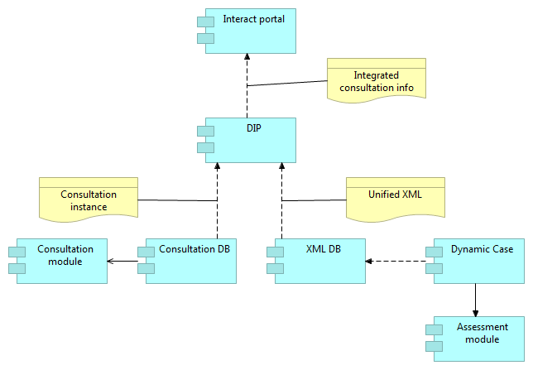

* Dynamic Case exposes information through the Unified XML (containing process map, case, event & assessment point information)
* Consultation module DB keeps timestamps on all entities so that change detection can be achieved
* Consultation module DB exposes a set of views to be used as interface towards DIP
* DIP consumes information from the Unified XML and from Consultation DB interface
* DIP integrates information and exposes the information for consumption by Interact Portal
* Interact Portal identifies the changed information of relevance and performs necessary operations, e.g. notifications to consultees etc.

## High Volume triggering

### Context

Until now, the consultation triggering process in Dynamic Case could take place in a case by case basis: For each case for which Case workers want to trigger a consultation, the user must perform a series of actions, such as navigating to the case and configuring the elements of the consultation. This process is deemed inefficient where the same consultation instance must be triggered for a group of cases. This becomes evident for the Dossier Evaluation process, where consultations must be triggered for a group containing more than 100 cases.

For **consultations published to Interact Portal**, the large number of notification that the consultees would receive for consultations effectively belonging to the same case group, would make harder for them to keep track with other useful notifications in their Interact Portal inbox. In addition, the consultees would need to be able to identify the consultations referring to the same case group so that they can easier work with them.

It is obvious that there is need for DyCa case actors to **trigger a consultation "batch"** for a group of cases, significantly reducing the manual effort required and by adapting the Consultation Tool’s data model to associate these consultations with their batch and the case they correspond to. As a consequence, the definition of two new terms are introduced:

* **Case group:** A set of DC cases of the same BAP that belong to the same consultation batch.
* **Consultation batch:** A set of consultation instances that have the same configuration where each consultation corresponds to a different DC case of the same group.

### Functionality

The new functionality of Consultation Tool provides to Case actors the opportunity to trigger a consultation batch for a group of cases - producing a consultation batch with the same number of Consultations as the number of Cases in the Case group. As a result, Case actor can group these consultations together. The “batch” is a list of cases and corresponding consultations with a 1-1 relationship (each consultation in the batch corresponds to one and only one case). Case actors can group these consultations together and have them published at the same time to the corresponding publishing system.

For every batch of Consultations is defined obligingly:

1. **Batch name:** The name for the batch. It will appear in the batch search results when searching for a batch to add a consultation to.
2. **Group task title:** The default group task title configured for that consultation will be automatically displayed.
3. **Start date:** The start date that will be filled in will automatically apply for the consultation being triggered and all subsequent consultations added to that batch.
4. **Deadline:** The deadline that will be filled in will automatically apply for the consultation being triggered and all subsequent consultations added to that batch.

In parallel, the DyCa Case actor can trigger separately a consultation and add it to an existing consultation batch.

## Data latency publication

Due to the dynamic nature of the preparation of the documents for consultation in many cases it is not possible to guarantee that all information for a consultation can be prepared and ready to be published one day (24-28 h) before. It was however detected the importance of having information in Interact Portal reliably updated in a frequent basis, (i.e. ~4) hours between the triggering / update event in DC and the relevant information update in the publishing channel (Interact Portal).

The reduction in the data latency is targeting to only affect consultations with Interact Portal as publishing channel (authority consultations) and this will happen by increasing the frequency by which DMP refreshes its data from the Consultation Tool’s database, from daily to several times per day.

DMP will refresh the data from the Consultation Tool’s database multiple times per 24-hour cycle, according to a predefined schedule. The same schedule will be followed for refreshing consultation data from DMP to Interact Portal.

Note that the refresh schedule will be configurable in both DMP and Interact Portal and thus can be subject to further adjustments in the future.

* 09:00 am
* 12:00 am
* 15:00 am
* 18:00 am
* 21:00 am
* 24:00 pm
* 06:00 am

Note that the schedule of Dynamic Case data loading process will not changes, it will remain in the way that is performed still today. This means that the process will still happen on a daily basis at ~07:00pm. Based on that, we can identify edge scenarios where the consultee’s experience when browsing the consultation page in Interact Portal can be affected by the eventual consistency that can be caused due to the difference in timings between the refresh of consultation related and case related data.

## Support IP to link to ACT process details

Currently, on IP side, a consultation instance has no link available to ACT process details view for consultations published via "SEV Decisions" BAP. The link is available for consultations published from "SEV Substances" BAP.

Both "SEV Substances" (parent case) and "SEV Decisions" (child case) belong to the same process map. There is a need to change the current functionality and display the link for consultations launched from "SEV Decisions" to point to the parent case "SEV Substances" under ACT->Process Details for cases where information on ACT is consolidated at the RML ID/process map level.

It should be noted that the functionality should **not be limited** to the above process only but should apply to all processes where applicable.

This request is translated to a more generic business need: Interact Portal system should be able to identify **if a case is a "parent" or a "child" in a Process map instance**. In general, consultation information is provided to IP via BIDI interface as produced in Consultation module (Toolbox). To address this request **two possible architectural scenarios** were examined in the analysis meeting with all involved stakeholders.

1. Update the existing consultation view adding the required information i.e., data element to define whether the case concerning the consultation was a root ("parent") or a leaf ("child")
2. Update the Case view provided already in the BIDI interface with IP capturing the tag Level as depicted in the DyCa XML files on BAP level. Having available this data element IP can figure out if a Case could be considered as parent or child. The set of permissible values is: 0 (root/parent case), 1,2,3, 4..(leaf/child case)

It is proposed to follow the second scenario due to the following reasoning:

* The information already exists on the BIDI side and more specifically in the EDH area as decomposed from the Unified xml. BIDI could upgrade the Case entity (view) appending the column Level in correspondence of the tag element Level of the XML file.
* No action is anticipated on the Toolbox side given that:
  + Consultation module could remain isolated/“unpolluted” from Case information as produced in the DyCa system
  + Consultation tool will move towards being a standalone tool and will not feed information to other systems
* IP will have the opportunity to apply the business logic required to support its business need.

This approach, proposed by BIDI, has been **communicated and agreed** with all involved parties (BIDI/IP/DyCa).

# EDM Coverage Conceptually

The conceptual approach below provides a brief description of the data domains that are involved and affected conceptually on enterprise level.

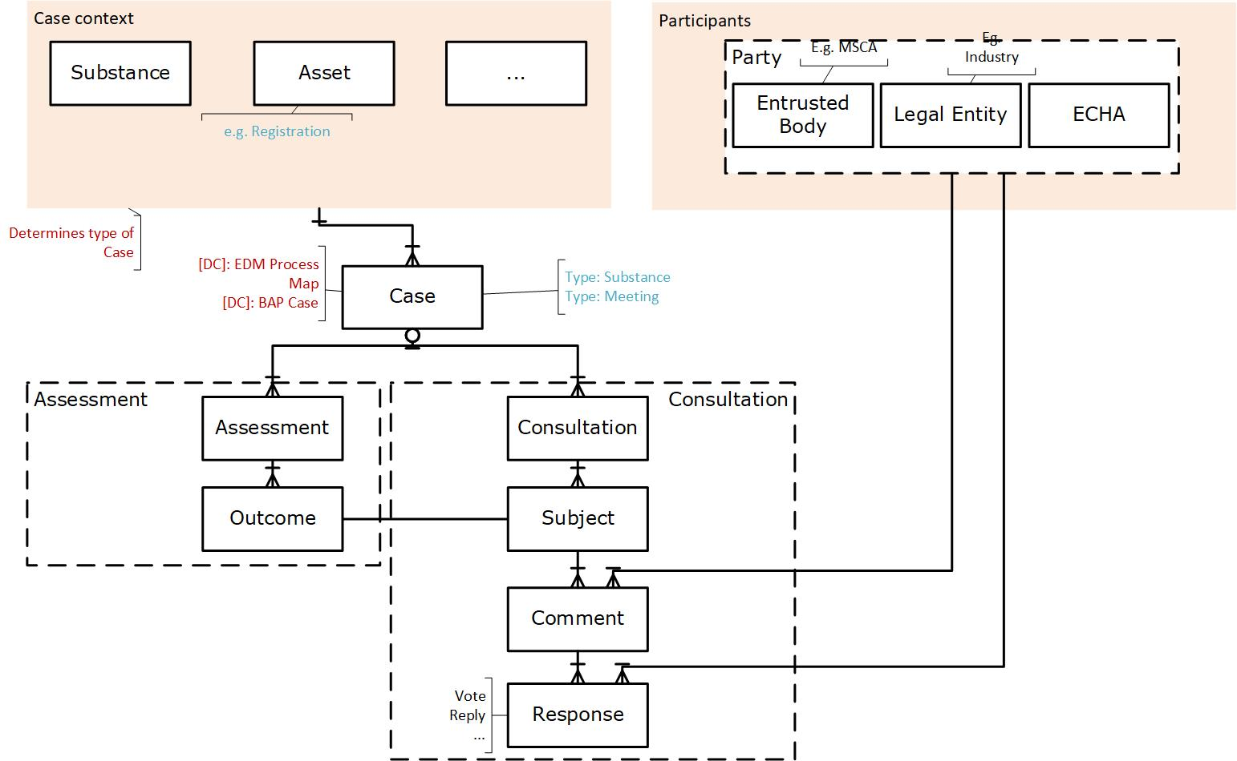

In general terms, in the model participate a) The Case context entities that determine the type of the Case b) The participants that constitute the roles that are involved (e.g. ECHA, MSCA, Industry), c) The Case hierarchy (as it is also structured in the Unified XML interface between DyCa and DMP: Case, Case event, Assessment, Outcome) and finally d) The consultation context where the Consultation and the Subjects of consultations are located along with the Comments to the Subjects and the feedback (Response) by the organization.

Detailed **Logical Data Model** of the Consultation area in presented in [Part E](#_Logical_Data_Model) of the current document.

# Assumptions & Constraints

Assumptions are events or circumstances that are expected to occur during the project life-cycle and therefore a source of a potential project risk.

* The **synchronization processes** between the interfaces can be carried out more frequently and differently aiming to achieve the publication of the authority consultation to Interact portal “within the day”. Towards this direction:
  + For consultation information, the usual XML interface between the source (Consultation Tool) and DMP will be omitted. A direct link to the CT data base will be used instead.
  + A dedicated flow will be set up by DMP to retrieve only Consultation data and make them available independently of the rest DMP functionality
* The pace of refreshing consultation data available for IP is described in section [Data latency publication](#_Data_latency_publication). IP has to set up to retrieve data accordingly.

PART B Functional Requirements

# Use Cases

A use case present the list of actions or event steps typically defining the interactions between a role (known as an actor) and a system to achieve a goal. The actor can be a human or other external system. Use Cases are used to explain how the system should behave and in the process and to ensure that business requirements are covered.

## UC-CONS-01. Retrieve data related to Authority Consultations

|  |  |
| --- | --- |
| **Use Case Description:** | **This use case allows Interact Portal to consume from BIDI on daily basis consultation related information.** |
| **Actors:** | AC-01, AC-02, AC-03, AC-04 |
| **Preconditions:** | 1. Consultation information has been propagated properly by AC-04 (Consultation Tool source system) to AC-02 (DMP). |
| **Main scenario:** | The following data elements should be integrated in DMP:   * General administrative information of the consultation. * List of ECHA Consultees * List of external Consultees. * Consultation basic data. * Documents. * Substance data or case related * Meeting related case * Consultation metadata |
| **Post Conditions:** | Authority consultation data elements are available to AC-01 through agreed access layer interface with AC-02. |
| **EPIC Number(s):** |  |
| **Notes:** |  |

## UC-CONS-02. Propagate data to Interact Portal

|  |  |
| --- | --- |
| **Use Case Description:** | **This use case allows Interact Portal to consume from BIDI on daily basis consultation related information.** |
| **Actors:** | AC-01, AC-02 |
| **Preconditions:** | 1. Consultation information that are of IP interest (AC-01) are integrated successfully in AC-02 (DMP). |
| **Main scenario:** | Integrated data elements should be available in DMP:   * Structured Authority Consultation information (administrative information of the consultation, Documents, etc.). * High Volume triggering data elements |
| **Post Conditions:** | AC-01 (Interact Portal) consumes data elements through the agreed access layer interface with DMP. |
| **EPIC Number(s):** | [DATA-3222](https://pmo.trasys.be/jira/browse/DATA-3222) |
| **Notes:** |  |

# IP Data Requirements

The interface that the Data Management platform will expose to end users for consumption is determined by the set of the requirements provided by IP. For data elements marked with (\*), more detailed clarifications regarding their availability are provided. Every piece of information is going to be retrieved from DyCa. In the following table are presented the required data elements as defined by IP. Data elements related with High Volume triggering and are part of the data model extension to support this feature are marked with [New for HVT] indication.

|  |  |  |  |  |  |  |  |  |
| --- | --- | --- | --- | --- | --- | --- | --- | --- |
| **Data name** | **Definition** | **Data type** | **Data format** | | **Optionality** | **Comment** | **Data in mockup** | **Use cases /Mockups** |
| **General administrative information of the consultation** | | | | | | | | |
| Consultation title | The consultation name that is given by the consultation creator for the running consultation | string |  | | Mandatory |  | Title | UC5 |
| Consultation type ***\**** | Public/**Authority** or **both**  ***DMP Note: The “both” option is not going to be applied in this version of the model but in future iteration for which the source system has to notify all involved stakeholders.*** | string |  | | Mandatory |  | Type | UC5 |
| Start date | When the consultation opens | date | dd-mm-yyyy | | Mandatory |  | Start of consultation | UC1-UC4 |
| End date | Deadline for the comments | date | dd-mm-yyyy | | Mandatory |  | Deadline for commenting | UC1-UC4 |
| Duration of the consultation ***\**** | Duration of the consultation | number | NN | | Mandatory |  | Used for calculations | UC1-UC4 |
| **[New for HVT]**  Consultation Group ID | The consultation Group ID defined, if this consultation is part of a group | number |  | | Optional | Empty if the consultation is not part of a group |  |  |
| **[New for HVT]**  Group name | The consultation Group name defined, if this consultation is part of a group | string |  | | Optional | Empty if the consultation is not part of a group |  |  |
| **[New for HVT]**  Is Master | Whether this is a master consultation or not, only applicable if the consultation is part of a group | numeric | 0/1 | | Optional | Empty if the consultation is not part of a group, 1 for master consultation of a group, 0 for the rest consultation in the group |  |  |
| **[New for HVT]**  Group Task Name | The task description that will appear in IP for the master task that will group all relevant sub-tasks for consultations in the same group. | string |  | | Optional | New field in DyCa, entered in consultation triggering specifically for the master consultation. Empty if the consultation is not part of a group |  |  |
| Reminder | The reminder is the number of days before the end date a reminder notification which shall be sent to the consultee | number | NN | | Mandatory |  | Used for notification trigger | UC1-UC4 |
| **List of ECHA Consultees** | | | | | | | | |
| User id of all the consultees | ECHA user ids (Active Directory group is discussed to be created) | string |  | Mandatory | |  | Used for task/notification handling and rights | UC1-UC4 |
| **List of external Consultees** | | | | | | | | |
| User group id (AD role) of the external consultee to the consultation ***\**** | External user group ids | string |  | Mandatory | |  | Used for task/notification handling and rightsParticipants | UC1-UC4 |
| User id of the consultee | External user ids | string |  | Mandatory | |  | Used for task/notification handling and rights | UC1-UC4 |
| **Consultation basic data** | | | | | | | | |
| Subject(s) | *Example -scenario:*  *There is a document which is the object of the consultation and for which a list of subjects is composed. These subjects are attributes of the consultation-case-xml.*  *In case of a substance case instance reference within the consultation this case instance refers to the consultation which may include many subjects (at least one).* | list |  | Mandatory | | one tag in xml per subject TBD | Consultation Subject(s) | UC7 |
| Subject-response optionality | Mandatory / Optional indication for the consultee to give response |  |  | Mandatory | |  | Consultation Subject(s) exclamation mark | UC7 |
| Subject order | The order of the subjects the users fill in. |  |  | Mandatory | |  | Order | UC7 |
| Consultation update type ***\**** | launched consultation  aborted consultation  updated consultation deadline  consultation update in documents  consultation update in metadata |  |  | Mandatory | | TBD maybe calculation of combination of attributes | Used for task/notification handling and rights | UC1-UC4 |
| **Documents** | | | | | | | | |
| Document name |  |  |  | Optional | |  | Document name | UC11 |
| Document version |  |  |  | Optional | |  | * Used for notification calculation | UC11 |
| Document reference id |  |  |  | Optional | |  | * Used to retrieve the document from WOPI | UC11 |
| Document confidentiality |  |  |  | Optional | |  | * Used for rights | UC11 |
| Document type ***\**** | **[Updated for HVT]**  Documents discrimination as Main, Supporting, General  ***DMP Note: One more option is added to support High Volume Triggering functionality*** |  |  | Optional | |  | Type | UC11 |
| Substance data or case related | | | | | | | | |
| Related DC Substance Case ID | The substance case which is referenced in the consultation, if any  Information both for the case and the instance that the consultation refers to | string |  | Optional | | linking to ACT on the Interact Portal | Used to retrieve information and case number in task | UC9 |
| RML ID | The substance which is referenced in the consultation, if any | string |  | Optional | |  | Used to retrieve information | UC9 |
| BAP name | The name of the BAP | string |  | Optional | |  | Consultation context | UC9 |
| **Meeting related case** | | | | | | | | |
| Related DC Meeting Case ID | The substance case which is referenced in the consultation, if any  Information both for the case and the instance that the consultation refers to | string |  | Optional | | linking to ACT on the Interact Portal | Used to retrieve information and case number in taks | UC8 |
| BAP name | The name of the BAP | string |  | Optional | |  | Consultation context | UC8 |
| **Standard related case - Other case *\**** | | | | | | | | |
| Related DC Standard Case IDMeeting case id***\**** | The standard case which is referenced in the consultation, if any  Information both for the case and the instance that the consultation refers toThe case which is referenced in the consultation, if any  Information both for the case and the instance that the consultation refers to | string |  | Optional | | linking to ACT on the Interact Portal | Used to retrieve information and case number in taks | UC10 |
| BAP name***\**** | The name of the BAP | string |  | Optional | |  | Used to retrieve information | UC10 |
| Working group name***\**** | The working group for which the case is opened(e.g. BPRS or FORUM WG) |  |  |  | |  | Consultation context | UC10 |
| **Consultation metadata** | | | | | | | | |
| Comments Responsible  (DC has not finalized the name of this data-field ) | The responsible:  to open the consultation case;  to handle the input aggregation of the comments received. Responsible to handle procedurally the consultation | string | Users or Groups | Mandatory | |  | Consultation Main Responsible | UC5 |
| Consultation status | The lifecycle status of consultation | string | LOV to be retrieved by DC (Active/Closed) | Mandatory | | TBD  *or dates to be somehow considered* | Status dropdown | UC5 |

**Note:** In [Appendix E](#_Logical_Data_Model) is presented in detail the logical data model that contains Consultation information but also the mapping of data elements between the source and consuming system.

It is also noted that:

* Duration of the consultation can be calculated having the start and end date of the Consultations
* The group of the User (User group id (AD role) of the external consultee to the consultation) is not provided by the source system. This issue has been subject of discussion in ECHA Architecture meetings
* **“Standard related case”** data elements has been considered out of scope at least for this phase of the project
* Data element **“Consultation update type”** is not provided as such by the source system. This is used by Interact Portal to define for task/notification handling and rights. As a general rule, Notifications are going to be produced by the consuming system (IP). This type of information can be derived from changes/updates made in the provided interface given the audit columns.
* The **“both”** option is not going to be applied in this version of the model but in future iteration for which the source system has not notify all involved stakeholders. If it would applied, IP should not retrieve only “Authority” but also “Both” Consolation instances. In that case, also some data elements for Third Party Consultation would be available in the interface. In matter of fact, this factor is not yet confronted by the source system, so the “both” option is postponed.
* In the reference List of Values **Document type**, the option **“General”** has been added. It refers to documents that are originated from a batch of Consultations and are common for all of them. It should be mentioned that following this approach a piece of information gets missing since if a document is characterized as “General”, common for all consultations of a batch, it does not mean that it is not Main or Supportive. Nevertheless, this assumption has been accepted from ECHA business users. DMP promotes to IP the values that the source system provides.
* The field **“Case Nickname”**, which is available on the case-level, will be provide by DyCa interface as a Consultation attribute (Case number is already defined as consultation attribute). Case nick name is a nickname given to a case, for easy identification. It is an existing field in DyCa but its source needs to be altered, and point to a different DyCa field according to each consultation type, within a process. This change will be performed by DyCa and will provided through the Consultation Tool interface to BIDI schema.

# Business Rules

This section provides a list of business rules that might have an impact on the work/business/domain that is the source of the requirements. Relevant business rules will be the trigger for requirements.

## Authority consultations

1. When consultation is triggered due to an Assessment that concluded to Hazard Finding, then the Subject of the Consultation will be the Hazard Class
2. Assessments built within DyCa environment should always be published before triggering a consultation. This rule will be implemented in DyCa User Interface. The reason is that only published Assessments of Dynamic Case are included in Unified XML files. Otherwise DMP could not identify the relation between Consultation and Case related information.
3. In the context of High Volume Triggering, there is only one “Master” consultation per batch i.e. It is noted that there is one and only one Consultation per Batch (This Consultation is derived from the initial Case based on which all Cases of the group are produced) that can be signed as “Consultation Batch Triggering point” equals “Yes”.

PART C Non functional Requirements

# Maintenance

* **DIP data refresh frequency**: DMP is refreshed on daily base. This means that the integrated data are one day back. Especially for Authority Consultation data, this refresh will take place multiple times per day.
* **DIP & DyCa synchronization frequency**: DIP integrates data from Dynamic Case (via XML files interface) once per day. This means that the integrated data are one day back.
* **DIP & Consultation module synchronization frequency**: DIP integrates data from Consultation module database multiple times per day.
* **DIP & IP synchronization frequency**: IP consumes data from DIP once per day. This means that the consumed data are one day back. For Authority Consultation data, IP can retrieve available data multiple times per day.

PART D Interface Requirements

# Inbound

This section provides specifications of the interface that the Data Management platform will use in order to integrate the relevant data from the source system. As mentioned, in the context of authority Consultations, the XML interface will not be used (On the contrary, for third party (public) consultations the XML interface cannot be avoided). For that reason, a direct access to the database model on which the Consultation tool is based, will be available.

At the time this document is formed, the most updated version of the model is the following:

* Regarding the exposed tables to BIDI:
* CONSULTATIONS [updated to support high volume triggering]
* BATCH\_INFO [created to support high volume triggering]
* BATCH\_CONTENTS [created to support high volume triggering]
* DOCUMENTS
* CONSULTATION\_USER
* CONSULTATION\_SUBJECT
* Additionally, configuration tables:
* CONSULTATION\_STATUS\_TYPE
* CONSULTATION\_TYPE
* PUBLISHING\_CHANNEL\_TYPE
* COMMENT\_ATTACHMENT\_TYPE
* CONSULTATION\_USER\_TYPE
* DOCUMENT\_TYPE
* SUBJECT\_DISPLAY\_TYPE
* COMMENT\_STATUS\_TYPE
* CONSULT\_CLASSIFICATION\_TYPE

The Consultation Tool’s database schema is depicted below over which the interface with DMP is built. It is a set of views populated with data retrieved from the native database. The initial data structure supports the Authority Consultation functionality and in May of 2020 it has been adjusted to support High Volume Triggering but also the Third party Consultations functionality (see [Adaptations to support high Volume triggering and Third party Consultations](#_Adaptations_to_support)).

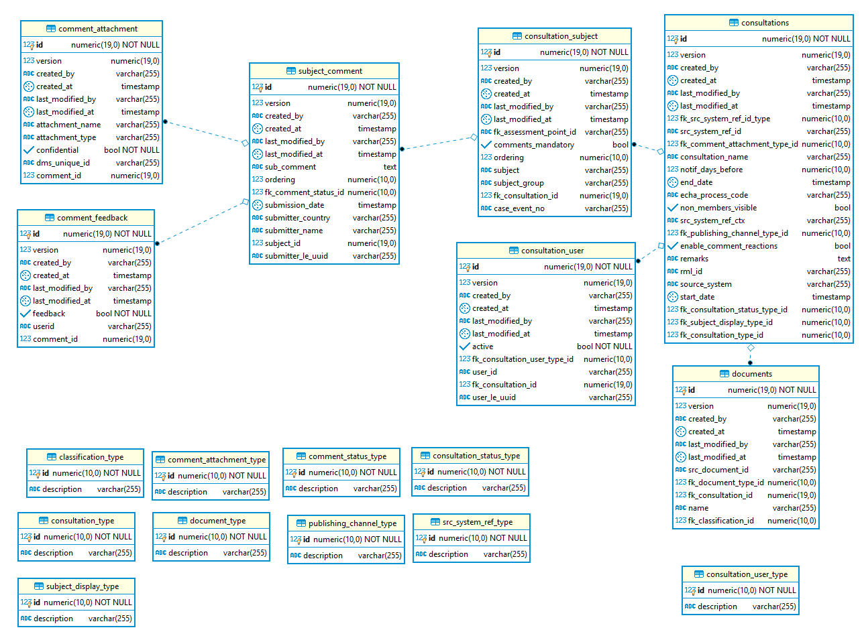This set of tables are finally exposed to DMP via a set of 4 views (1to 1 relationship with actual tables) and a set of reference supportive views that contain the available list of values:

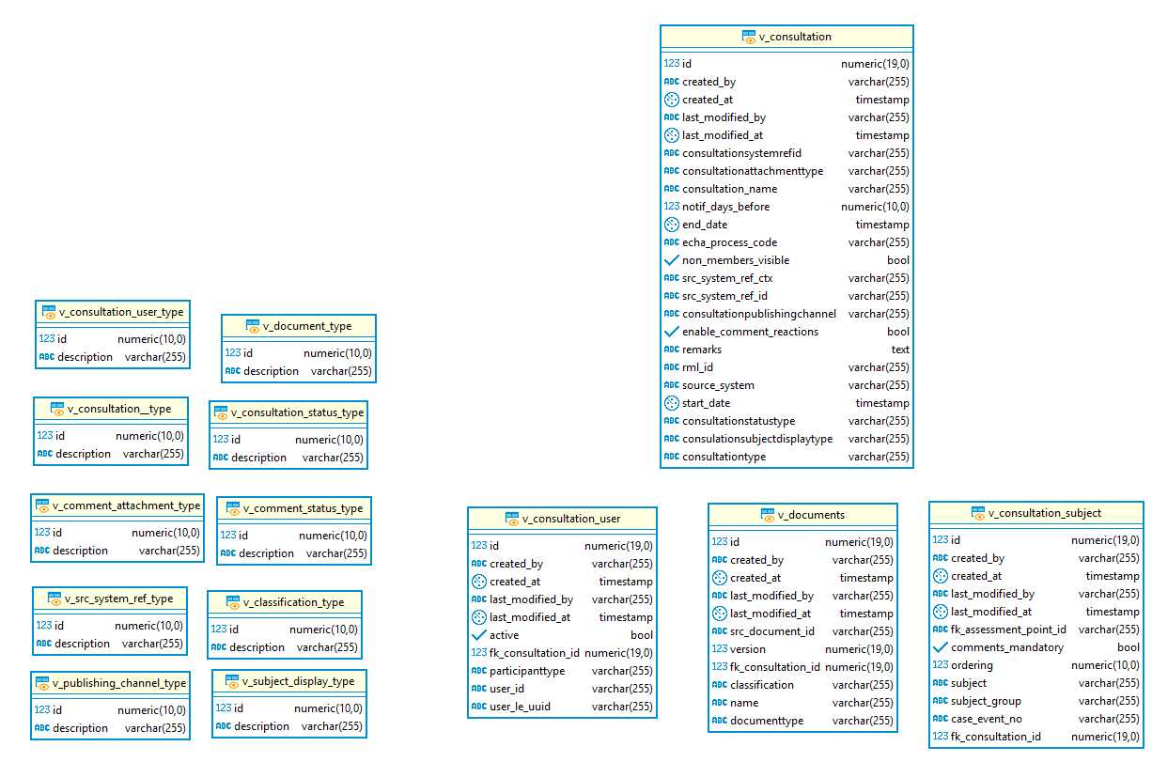

**Note:** In [Appendix E](#_Logical_Data_Model) is presented in detail the logical data model that contains Consultation information but also the mapping of data elements between the source and consuming system.

## Adaptations to support High Volume triggering and Third Party Consultations

The following tables present the adaptations required to support High Volume triggering and Third Party Consultations. Table rows or views highlighted in green refer to new views or new columns in existing views. Views without modifications have been omitted (e.g. v\_documents, v\_consultation\_user).

|  |  |  |
| --- | --- | --- |
| **v\_consultations** | | |
| **Attribute** | **Type** | **Description - Requirement** |
| id | Number | Unique ID for a Consultation |
| created\_by | Varchar | User ID of the user that created the consultation |
| created\_at | Date | Creation Date of the row |
| last\_modified\_by | Varchar | User ID of the user that modified the consultation |
| last\_modified\_at | Date | Modification Date of the row |
| consultationsystemrefid | Varchar | ‘Substance’ or ‘Meeting’ |
| consultationattachmenttype | Varchar | 'Disabled', 'Public Only', 'Allow Public and Confidential' |
| consultation\_name | Varchar | Name of the consultation |
| notif\_days\_before | Number | Notification days before |
| end\_date | Date | The date when the consultation ends |
| echa\_process\_code | Varchar | The codes of the activity & the process that corresponds to the consultation instance (e.g. 01.01) |
| non\_members\_visible | Boolean | Whether the consultation is visible only to its consultees. |
| src\_system\_ref\_ctx | Varchar | The identifier of the Case in the Source System. If Case is originated from DyCa, it contains the BAP name in DC |
| src\_system\_ref\_id | Varchar | The case number in DC |
| consultationpublishingchannel | Varchar | 'Interact Portal', 'ECHA Website' |
| enable\_comment\_reactions | Boolean | Whether the consultation allows consultees to post reactions to comments submitted by other consultees |
| remarks | Varchar | Comments made by Consultees on Consultation level |
| rml\_id | Varchar | RML ID of the case |
| source\_system | Varchar | The source application system where the Consultation is triggered |
| start\_date | Date |  |
| consultationstatustype | Varchar | The status which depicts the lifecycle of the Consultation : 'Not started', 'In progress', 'Finished', 'Aborted' |
| consulationsubjectdisplaytype | Varchar | The method to display information in Consumer side i.e. 'List', 'Drop down menu' |
| consultationtype | Varchar |  |
| consultclassificationtype | Varchar | Populated only for TP consultations  Possible values: Targeted, Multi-lingual |
| round\_no | Number | Populated only for TP consultations  The number of the round (e.g. 1,2,3) |
| round\_name | Varchar | Populated only for TP consultations  The round name |
| prev\_consultation\_id | Number | Populated only for TP consultations  The consultation id, predecessor of the current one |
| tp\_end\_date | Date | Populated only for TP consultations  TP consultation end date. Different than end\_date which is for authority consultation to support both deadlines in one consultation instance |
| case\_event\_no | Varchar | The Case event Number as it is defined in the Assessment module/DyCa |
| edm\_case | Varchar | The Process Map, in which the Case belongs |
| case\_nickname | Varchar | Case nick name is a nickname given to a case, for easy identification. |

|  |  |  |
| --- | --- | --- |
| **v\_batch\_info** | | |
| **Attribute** | **Type** | **Description - Requirement** |
| ID | Number | Unique ID for Batch |
| title | Varchar | The consultation Group name defined, if this consultation is part of a group |
| group\_task\_name | Varchar | The task description that will appear in IP for the master task that will group all relevant sub-tasks for consultations in the same group. |

|  |  |  |
| --- | --- | --- |
| **v\_batch\_contents** | | |
| **Attribute** | **Type** | **Description - Requirement** |
| fk\_batch\_id |  | Foreign key to batch info table |
| Fk\_consultation\_id |  | Foreign key to Consultations table |
| is\_triggering\_point |  | Is the main consultation that triggered the batch? |

|  |  |  |
| --- | --- | --- |
| **v\_consult\_classification\_type** | | |
| **Attribute** | **Type** | **Description - Requirement** |
| Consult\_classification\_id | Numeric |  |
| description | Varchar | Targeted or Multi-lingual |

# Outbound

IP consumes already a set of views that contain Authority Consultation information. In the context of high Volume Triggering, more entities have been available and minor additions or adaptations have been applied.

The list of views accessible for IP contains the following items:

* CONSULTATIONS [updated to support high volume triggering]
* BATCH\_INFO [created to support high volume triggering]
* BATCH\_CONTENTS [created to support high volume triggering]
* DOCUMENTS
* CONSULTATION\_USER
* CONSULTATION\_SUBJECT

In [Appendix E](#_Logical_Data_Model) of the document the Logical Data Model for Consultations is presented. At the same time is depicted the mapping between DMP Model and a) the corresponding data attribute in source system (see [Inbound](#_Inbound)) and b) the requirement as stated from the consuming system, IP (see [IP Data Requirements](#_IP_Data_Requirements)).

In next section, the physical interface of DMP regarding Consultations Data Domain is presented analytically. It includes all adaptations needed to support the High Volume Triggering functionality.

## Physical Interface for Consultations data domain

PART E APPENDIX

# Logical Data Model

In this of the document the Logical Data Model for Consultations is presented. At the same time is depicted the mapping between DMP Model and a) the corresponding data attribute in source system (see [Inbound](#_Inbound)) and b) the requirement as stated from the consuming system, IP (see [IP Data Requirements](#_IP_Data_Requirements)).

## Master data

### Consultation

|  |  |  |  |  |  |  |
| --- | --- | --- | --- | --- | --- | --- |
| **Consultation** | | | | | | |
|  | **Attribute** | **Mandatory** | **Data type** | **Column in Source**  **[v\_consultation]** | **Business meaning** | **IP requirement** |
| 1 | Consultation Id | Yes | Numeric | id | Unique ID for a Consultation |  |
| 2 | Consultation Name | Yes | Varchar | consultation\_name | Name of the consultation | Consultation title |
| 3 | Consultation Type | Yes | Numeric | Consultationtype | 'Authority'  'Public' | Consultation type |
| 4 | Consultation Cause  [REF. ENT. Consultation Cause] | Yes | Varchar | consultationsystemrefid  REFERENCE ENTITY | ‘Substance’ or ‘Meeting’ |  |
| 5 | Start date | Yes | Date | start\_date | The date when the consultation starts (is visible in the publishing channel and the consultees can provide comments) | Start date |
| 6 | End date | No | Date | end\_date | The date when the consultation ends | End date |
| 7 | Case id | Yes | Numeric | src\_system\_ref\_id | The case number in DC | Related DC Substance Case ID |
| 8 | Case identifier in source | Yes | Varchar | src\_system\_ref\_ctx | The identifier of the Case in the Source System. If Case is originated from DyCa, it contains the BAP name in DC | BAP name |
| 9 | Attachment Type id  [REF. ENT. Attachment Type] | Yes | Varchar | consultationattachmenttype  REFERENCE ENTITY | 'Disabled'  'Public Only'  'Allow Public and Confidential' |  |
| 10 | Notification days before | No | Integer | notif\_days\_before | How many days before the deadline should the consultees be notified. | Reminder |
| 11 | Organization Process | No | Varchar | echa\_process\_code | The codes of the activity & the process that corresponds to the consultation instance (e.g. 01.01) |  |
| 12 | Non Members visible | Yes | Boolean | non\_members\_visible | Whether the consultation is visible only to its consultees. |  |
| 13 | Publishing  Channel  [REF. ENT. Publishing  Channel] | Yes | Numeric | consultationpublishingchannel [REF. ENT. v\_publishing\_channel\_type] | 'Interact Portal'  'ECHA Website' |  |
| 14 | Enable comments | Yes | Boolean | enable\_comment\_reactions | Whether the consultation allows consultees to post reactions to comments submitted by other consultees |  |
| 15 | Remarks | No | CLOB | remarks | Comments made by Consultees on Consultation level |  |
| 16 | Substance id | No | Numeric | rml\_id | RML ID of the case | RML ID |
| 17 | Source system | Yes | Varchar | source\_system | The source application system where the Consultation is triggered |  |
| 18 | Consultation Status Id  [REF. ENT. Consultation Status] | Yes | Varchar | consultationstatustype | The status which depicts the lifecycle of the Consultation : 'Not started', 'In progress', 'Finished', 'Aborted' | Consultation status |
| 19 | Display Type Id  [REF. ENT. Consultation Display Type] | Yes | Numeric | consulationsubjectdisplaytype | The method to display information in Consumer side i.e. 'List', 'Drop down menu' |  |
| 20 | Created by | Yes | Varchar | created\_by | User ID of the user that created the consultation |  |
| 21 | Create Date | Yes | DateTime | created\_at | Creation Date of the row |  |
| 22 | Modified by | No | Varchar | last\_modified\_by | User ID of the user that modified the consultation |  |
| 23 | Modify Date | No | DateTime | last\_modified\_at | Modification Date of the row |  |
| 24 | Case Nickname | Yes | Varchar | case\_nickname | Case nick name is a nickname given to a case, for easy identification. | Case Nickname |

### Batch of Consultations (high volume triggering)

There are two entities that refer to the need to keep High Volume triggering information

* **Consultation Batch info:** contains the definition of all batches of Consultations.
* **Consultation Batch association:** provides the potential linking of a consultation with a batch of Consultations.

|  |  |  |  |  |  |  |
| --- | --- | --- | --- | --- | --- | --- |
| **Consultation Batch info** | | | | | | |
|  | **Attribute** | **Mandatory** | **Data type** | **Column in Source**  **[v\_batch\_info]** | **Business meaning** | **IP requirement** |
| 1 | Consultation Batch Id | Yes | Numeric | Id | Unique ID for a Consultation Batch |  |
| 2 | Consultation Batch Name | Yes | Varchar | title | The consultation Group name defined, if this consultation is part of a group | Group name |
| 3 | Consultation Batch Task name | Yes | Varchar | group\_task\_name | The task description that will appear in IP for the master task that will group all relevant sub-tasks for consultations in the same group. | Group Task Name |
| 4 | Consultation Type | Yes | Varchar | fk\_consultation\_type\_id | Column to identify the type of consultation this batch refers to (Authority or Third-party).  **Note:** IP has to filter out the Authority Consultation Batches |  |

|  |  |  |  |  |  |  |
| --- | --- | --- | --- | --- | --- | --- |
| **Consultation Batch association** | | | | | | |
|  | **Attribute** | **Mandatory** | **Data type** | **Column in Source**  **[v\_batch\_contents]** | **Business meaning** | **IP requirement** |
| 1 | Consultation Batch Id | Yes | Numeric | fk\_batch\_id  [foreign key to “Consultation Batch info” table] | Unique ID for a Consultation Batch | Consultation Group ID  *The consultation Group ID defined, if this consultation is part of a group* |
| 2 | Consultation Id | Yes | Numeric | fk\_consultation\_id  [foreign key to “Consultation” table] | Unique ID for a Consultation |  |
| 3 | Consultation Batch Triggering point | Yes | Boolean | is\_triggering\_point | True if this is the main consultation that triggered the batch. Only one “Master” consultation per batch. | Is Master  *Whether this is a master consultation or not, only applicable if the consultation is part of a group* |

### Consultation User

|  |  |  |  |  |  |  |
| --- | --- | --- | --- | --- | --- | --- |
| **Consultation User** | | | | | | |
|  | **Attribute** | **Mandatory** | **Data type** | **Column in Source**  **[v\_consultation\_user]** | **Business meaning** | **IP requirement** |
| 1 | Consultation User Id | Yes | Numeric | Id | Unique ID for a Consultation User | User id of all the consultees |
| 2 | Consultation Id | Yes | Numeric | fk\_consultation\_id  Foreign key to the consultation ID | Unique ID for a Consultation |  |
| 3 | User Type  [REF. ENT. Consultation User Type] | Yes | Numeric | participanttype | 'Comments Responsible'  'Consultee' | Comments Responsible |
| 4 | Active | Yes | Boolean | active | Indication for activated user |  |
| 5 | Group Name | Yes | Varchar | groupname | Group Name in which the user belongs to. |  |
| 6 | Username | Yes | Varchar | user\_id | User login name | User id of the consultee |
| 7 | External id  foreign key to the Party entity | Yes | Varchar | user\_le\_uuid | User legal entity UUID  **Note:** The value of the column will be always NULL.The Legal entity for which the User participates in a Consultation is not defined yet by the source system and/or Business Users. |  |
| 8 | Created by | Yes | Varchar | created\_by | User ID of the user that created the consultation |  |
| 9 | Create Date | Yes | DateTime | created\_at | Consultation Creation Date |  |
| 10 | Modified by | No | Varchar | last\_modified\_by | User ID of the user that modified the consultation |  |
| 11 | Modify Date | No | DateTime | last\_modified\_at | Consultation last Modification Date |  |

### Subject of Consultation

|  |  |  |  |  |  |  |
| --- | --- | --- | --- | --- | --- | --- |
| **Consultation Subject** | | | | | | |
|  | **Attribute** | **Mandatory** | **Data type** | **Column in Source**  **[v\_consultation\_user]** | **Business meaning** | **IP requirement** |
| 1 | Consultation subject Id | Yes | Numeric | Id | Unique ID for a Consultation Subject | User id of Consultation Subject |
| 2 | Consultation Id | Yes | Numeric | fk\_consultation\_id  Foreign key to the consultation ID | Unique ID for a Consultation |  |
| 3 | Event Id | No | Varchar | case\_event\_no | Case event number that corresponds to the subject |  |
| 4 | Outcome Id | No | Varchar | fk\_assessment\_point\_id | Assessment Point ID |  |
| 5 | Mandatory comments | Yes | Boolean | comments\_mandatory | Whether it is mandatory to comment on this subject in order to provide a comment | Subject-response optionality |
| 6 | Ordering | No | Numeric | ordering | The order in which a particular subject appears in the subjects section of the consultation page | Subject order |
| 7 | Subject |  | Varchar | subject | The name of the subject | Subject(s) |
| 8 | Subject group |  | Varchar | subject\_group | The group that the subject belongs to (used when enumerating large number of subjects in drop down list) |  |
| 9 | Created by | Yes | Varchar | created\_by | User ID of the user that created the consultation |  |
| 10 | Create Date | Yes | DateTime | created\_at | Creation Date of the row |  |
| 11 | Modified by | No | Varchar | last\_modified\_by | User ID of the user that modified the consultation |  |
| 12 | Modify Date | No | DateTime | last\_modified\_at | Modification Date of the row |  |

### Consultation Documents

|  |  |  |  |  |  |  |
| --- | --- | --- | --- | --- | --- | --- |
| **Consultation Document** | | | | | | |
|  | **Attribute** | **Mandatory** | **Data type** | **Column in Source**  **[v\_documents]** | **Business meaning** | **IP requirement** |
| 1 | Consultation Document Id | Yes | Numeric | Id | Unique ID for a Consultation Document |  |
| 2 | Consultation Id | Yes | Numeric | fk\_consultation\_id  Foreign key to the consultation ID | Unique ID for a Consultation |  |
| 3 | Name | Yes | Varchar | Name | The name of the document | Document name |
| 4 | Version | Yes | Varchar | version | The version of the document | Document version |
| 5 | Document Type  [REF. ENT. Consultation User Type] | Yes | Varchar | documenttype | The taxonomy of the document as Main or Supporting | Document type |
| 6 | Document Classification  [REF. ENT. Document Classification] | Yes | Varchar | classification | The classification of the document confidentiality i.e. Public, Internal, Restricted | Document confidentiality |
| 7 | Source document id | Yes | Varchar | src\_document\_id | The unique ID of the record in the source system that hosts the document | Document reference id |
| 8 | Created by | Yes | Varchar | created\_by | User ID of the user that created the consultation |  |
| 9 | Create Date | Yes | DateTime | created\_at | Creation Date of the row |  |
| 10 | Modified by | No | Varchar | last\_modified\_by | User ID of the user that modified the consultation |  |
| 11 | Modify Date | No | DateTime | last\_modified\_at | Modification Date of the row |  |

### Case entity

In the provided Case view, the column CASE LEVEL will be appended to support IP's need to identify if BAP Case is root/parent or leaf/child in a Process Map

|  |  |  |  |  |  |  |
| --- | --- | --- | --- | --- | --- | --- |
|  | CASE LEVEL | Yes | NUMBER | CASE\_LEVEL | Value of the BAP Case level | 0 (root/parent case), 1,2,3, 4..(leaf/child case) |

## Reference data

All reference data entities are formed in the pattern of two columns i.e. Id, Description. In the following table are summarized the mappings between LDM and source system reference entities and the permissible values for every List of values.

|  |  |  |  |  |  |  |
| --- | --- | --- | --- | --- | --- | --- |
| **Reference data mapping** | | | | | | |
|  | **View in LDM** | **Refers to Entity** | **Refers to Attribute** | **View in Source Schema** | **List of values** | **IP requirement** |
| 1 | Consultation Attachment Type | Consultation | Attachment Type id | v\_comment\_attachment\_type | 'Disabled'  'Public Only'  'Allow Public and Confidential' | Unique ID for this table FK to v\_consultations. Consultationattachmenttype |
| 2 | Document Consultation | Consultation Document | Document Consultation id | v\_classification\_type | 'Public'  'Internal'  'Restricted'  'Highly Restricted' | Unique ID for this table FK to v\_documents.classification |
| 3 | Consultation Status | Consultation | Consultation Status id | v\_consultation\_status\_type | 'Not started'  'In progress'  'Finished'  'Aborted' | Unique ID for this table FK to v\_consultations. Consultationstatustype |
| 4 | Consultation User type | Consultation User | User type id | v\_consultation\_user\_type | 'Comments Responsible'  'Consultee' | Unique ID for this table FK to v\_consultation\_user. participanttype |
| 5 | Consultation Document Type | Consultation Document | Document Type id | v\_document\_type | Main  Supporting | Unique ID for this table FK to v\_documents. documenttype |
| 6 | Publishing Channel | Consultation | Publishing Channel id | v\_publishing\_channel\_type | 'Interact Portal'  'ECHA Website' | Unique ID for this table FK to v\_consultation. Consultationpublishingchannel |
| 7 | Consultation Cause | Consultation | Consultation Cause id | v\_src\_system\_ref\_type | ‘Substance’  ‘Meeting’ | Unique ID for this table FK to v\_consultation. Consultationsystemrefid |
| 8 | Display Type | Consultation | Display Type id | v\_subject\_display\_type | 'List'  'Drop down menu' | Unique ID for this table FK to v\_consultation. consulationsubjectdisplaytype |
| 10 | Consultation Type | Consultation | Consultation Type id | v\_consultation\_type | 'Authority'  'Public' | Unique ID for this table FK to v\_consultation. Consultationtype |